Hostel Life Exposure Program for Promoting Inclusive Environment

Organised By: Department of Computer Science, Handique Girls’ College

Venue: Girls’ Hostel, Tezpur University

Date: 25th February, 2026

Participants: 6 students from BCA 2nd Semester

Faculty Name: Miss Trishna Smita Datta

Resource Person / Alumni: Miss Meenakshi Bordoloi (BCA 2022-25 batch, currently pursuing MCA at Tezpur University).

Description of the activity:
To promote an inclusive academic and social environment, 6 students of BCA 2nd semester students were taken for an exposure visit to the Girls’ Hostel at Tezpur University. The visit was facilitated by the department alumni Miss Meenakshi Bordoloi, who shared her experiences of hostel life, academic culture and opportunities for higher education.
During the interaction, students discussed the supportive residential environment, study culture, peer learning opportunities and facilities available to female students in a central university. The session helped students understand how hostel life encourages collaboration, independence and inclusive community living.
The interaction created a platform where students could freely ask questions about higher education, university life and research opportunities, thereby motivating them to pursue further studies.

Outcome
- Students gained first-hand exposure to hostel life in a university environment.
- The interaction promoted peer mentoring and alumni engagement.
- It encouraged female students to pursue higher education.
- The activity contributed to building an inclusive and supportive academic culture.

Evidences (geo-tagged photographs, attendance of students)
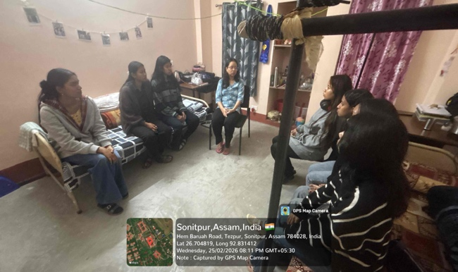 | 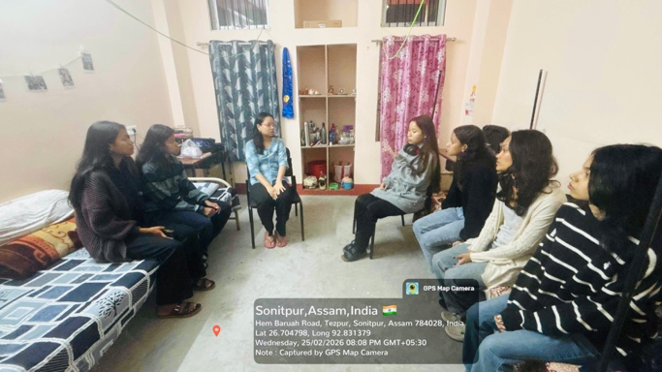
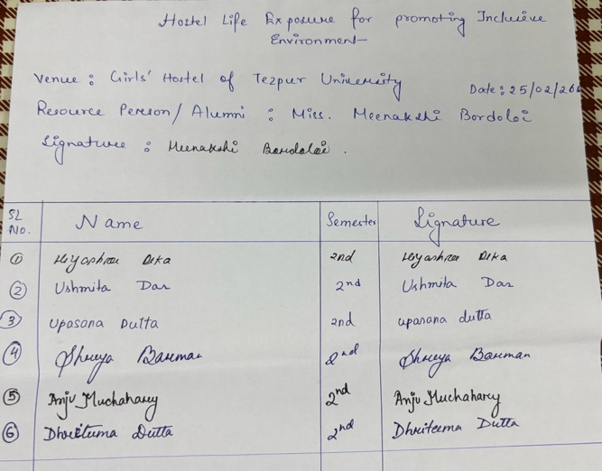 | 